Try to reproduce the issue in Pre-Prod.

Scenario 1) Same Dispute Type, different reasons

1st Dispute a 1201, 2nd dispute a 1202, 3rd Dispute a 1201

To reproduce the issue expect the 3rd dispute to incorrectly be grouped with 1st dispute.

Result – Issue was reproduced

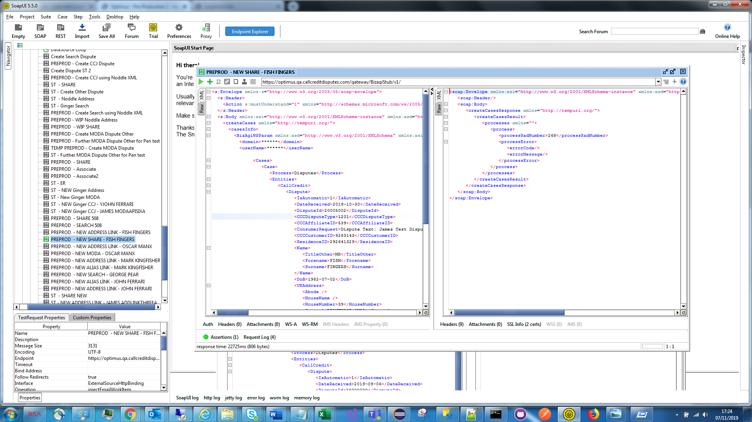

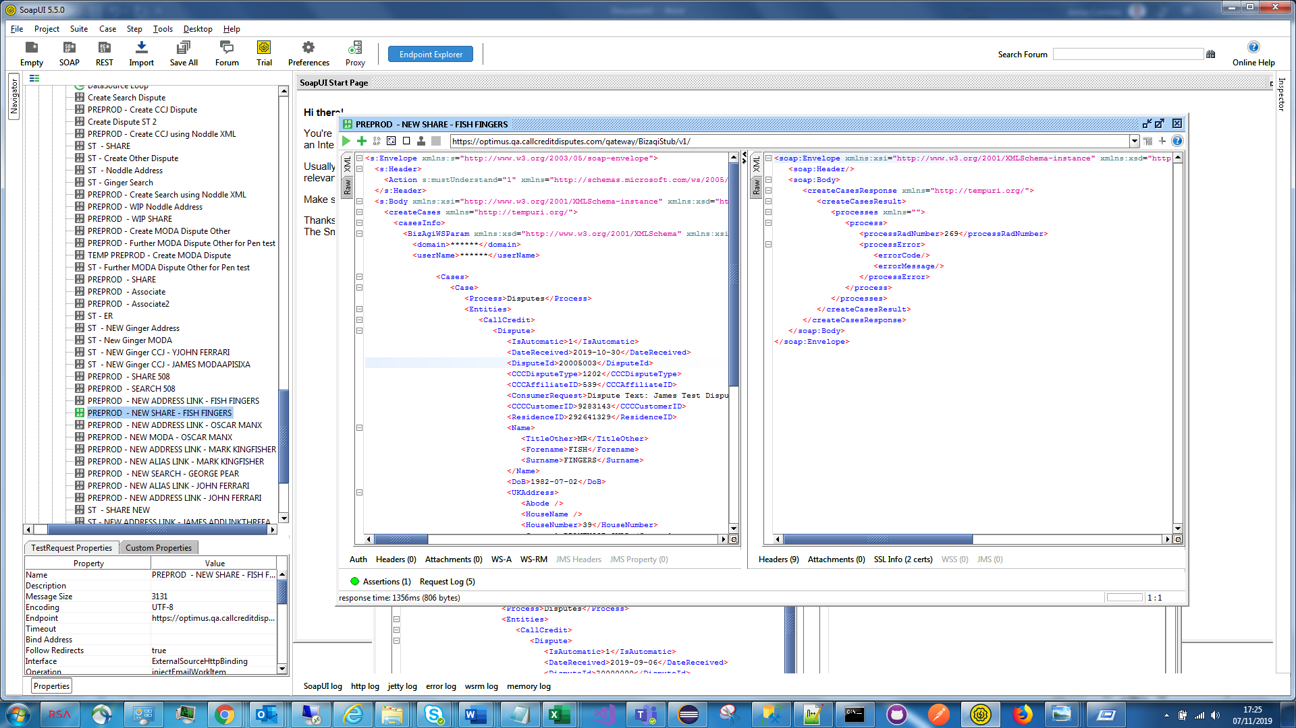

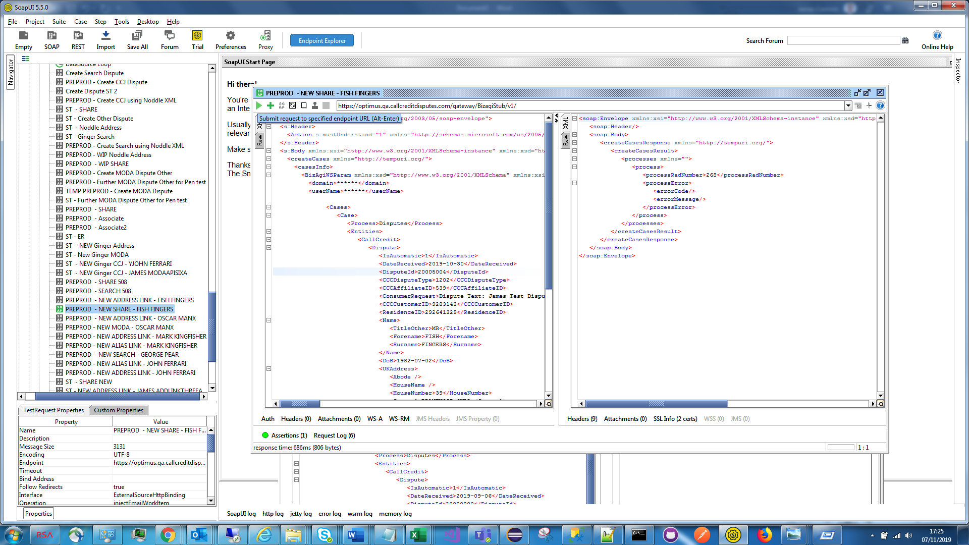

Scenario 2) Different Dispute Types

1st Dispute a 102, 2nd dispute a 301, 3rd Dispute a 301

To reproduce the issue expect the 3rd dispute to incorrectly be grouped with 1st dispute.

Result – Could not reproduce the issue

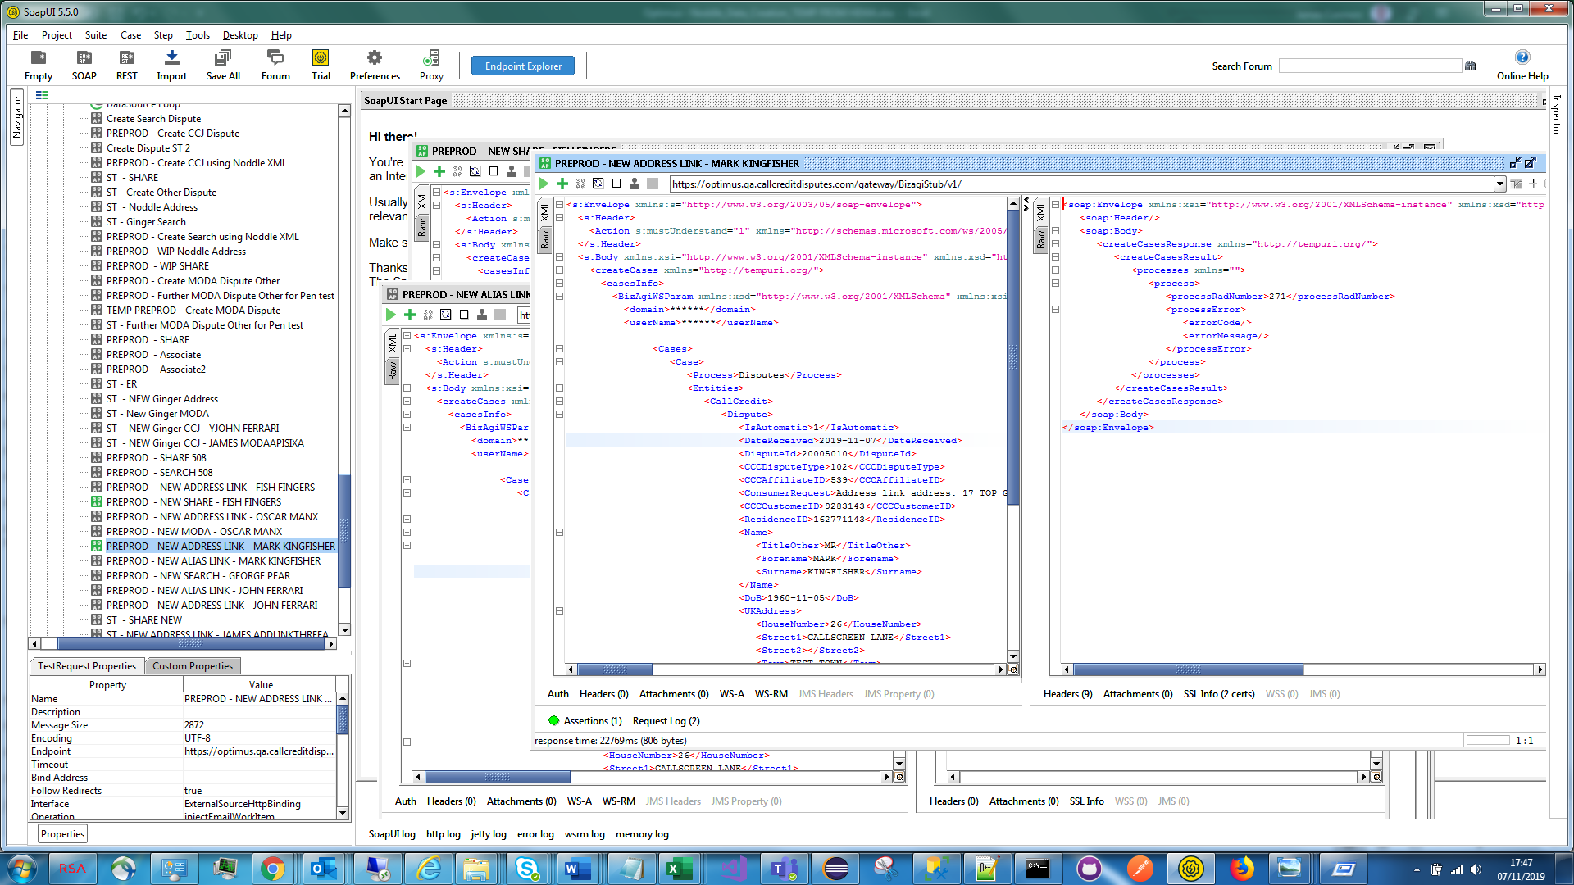

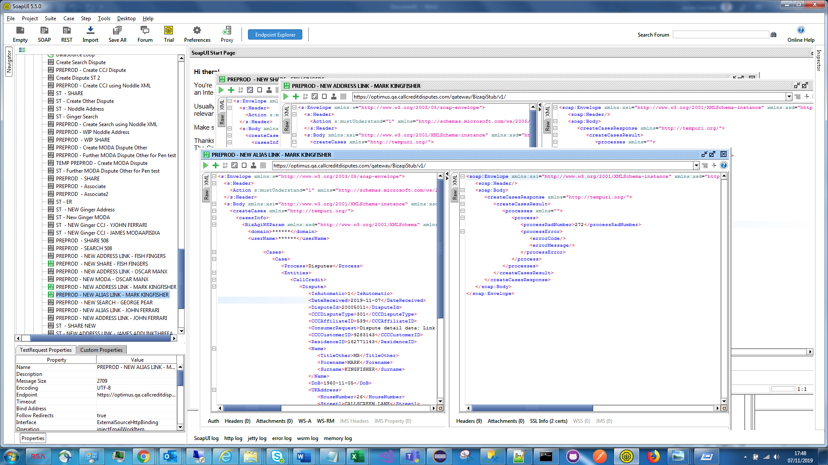

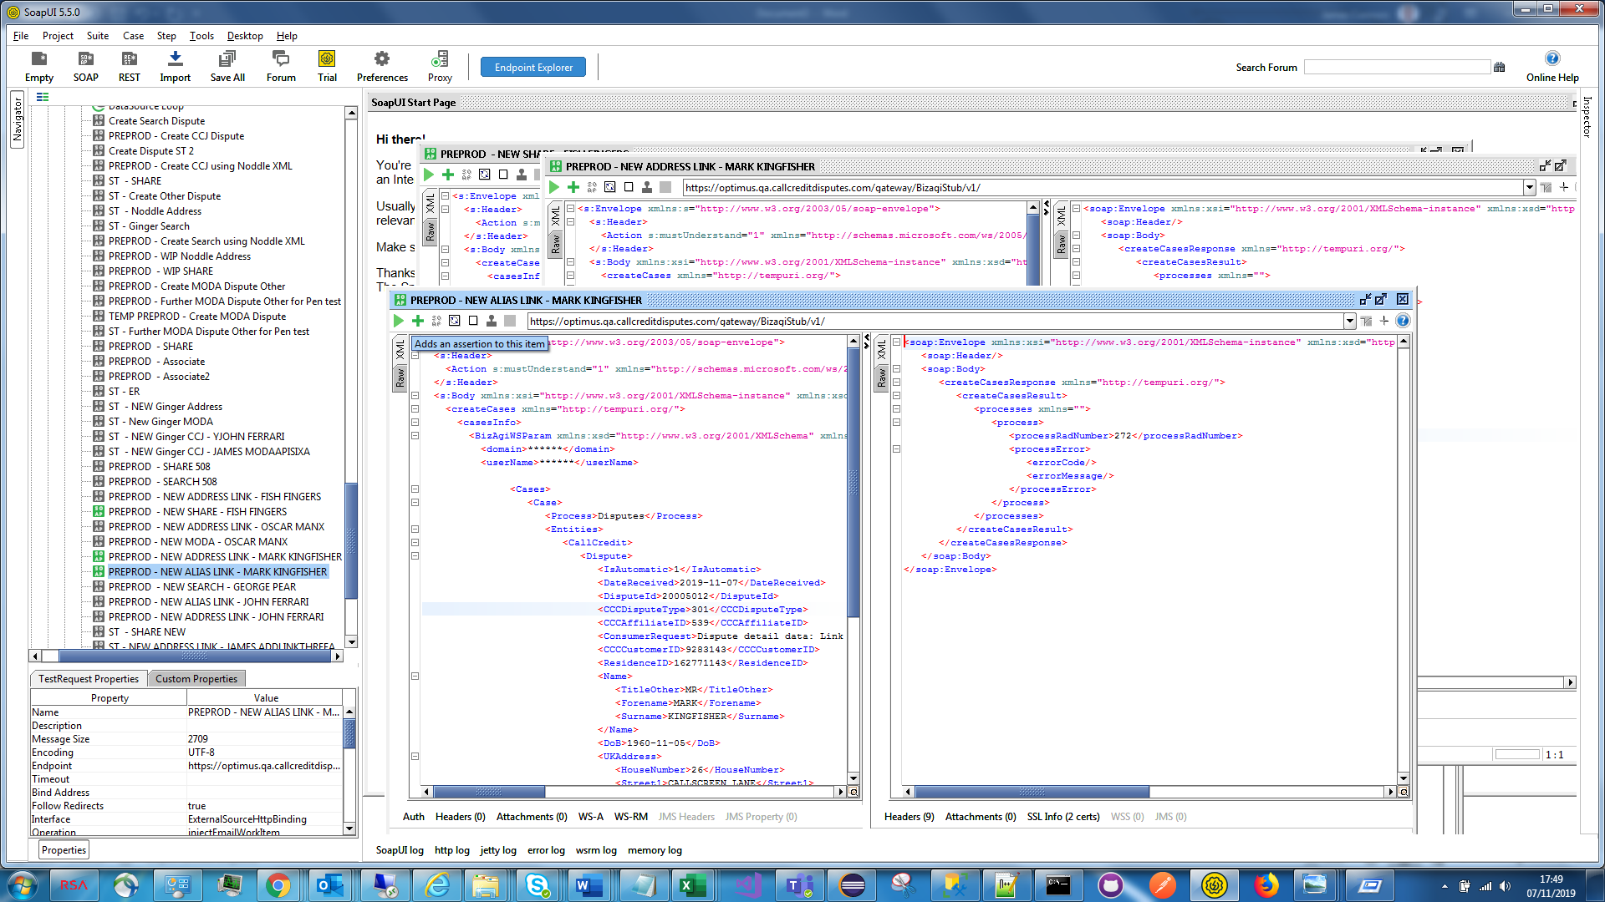

Preprod – Raise a Address Link Dispute, then an ER, then the same ER;

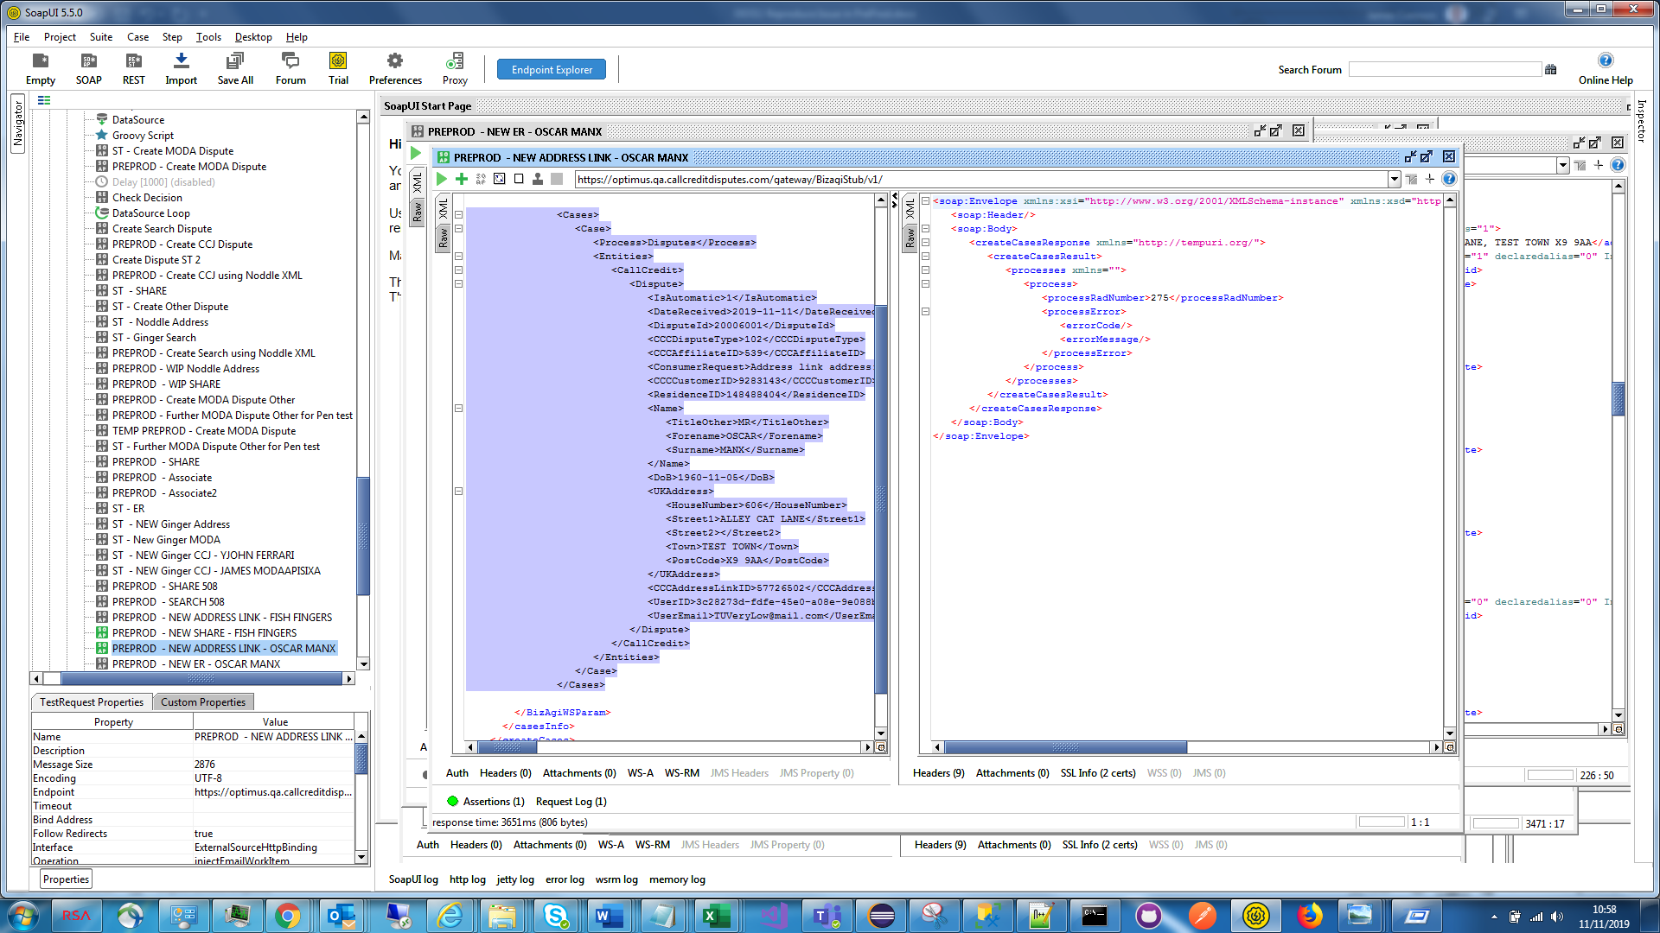

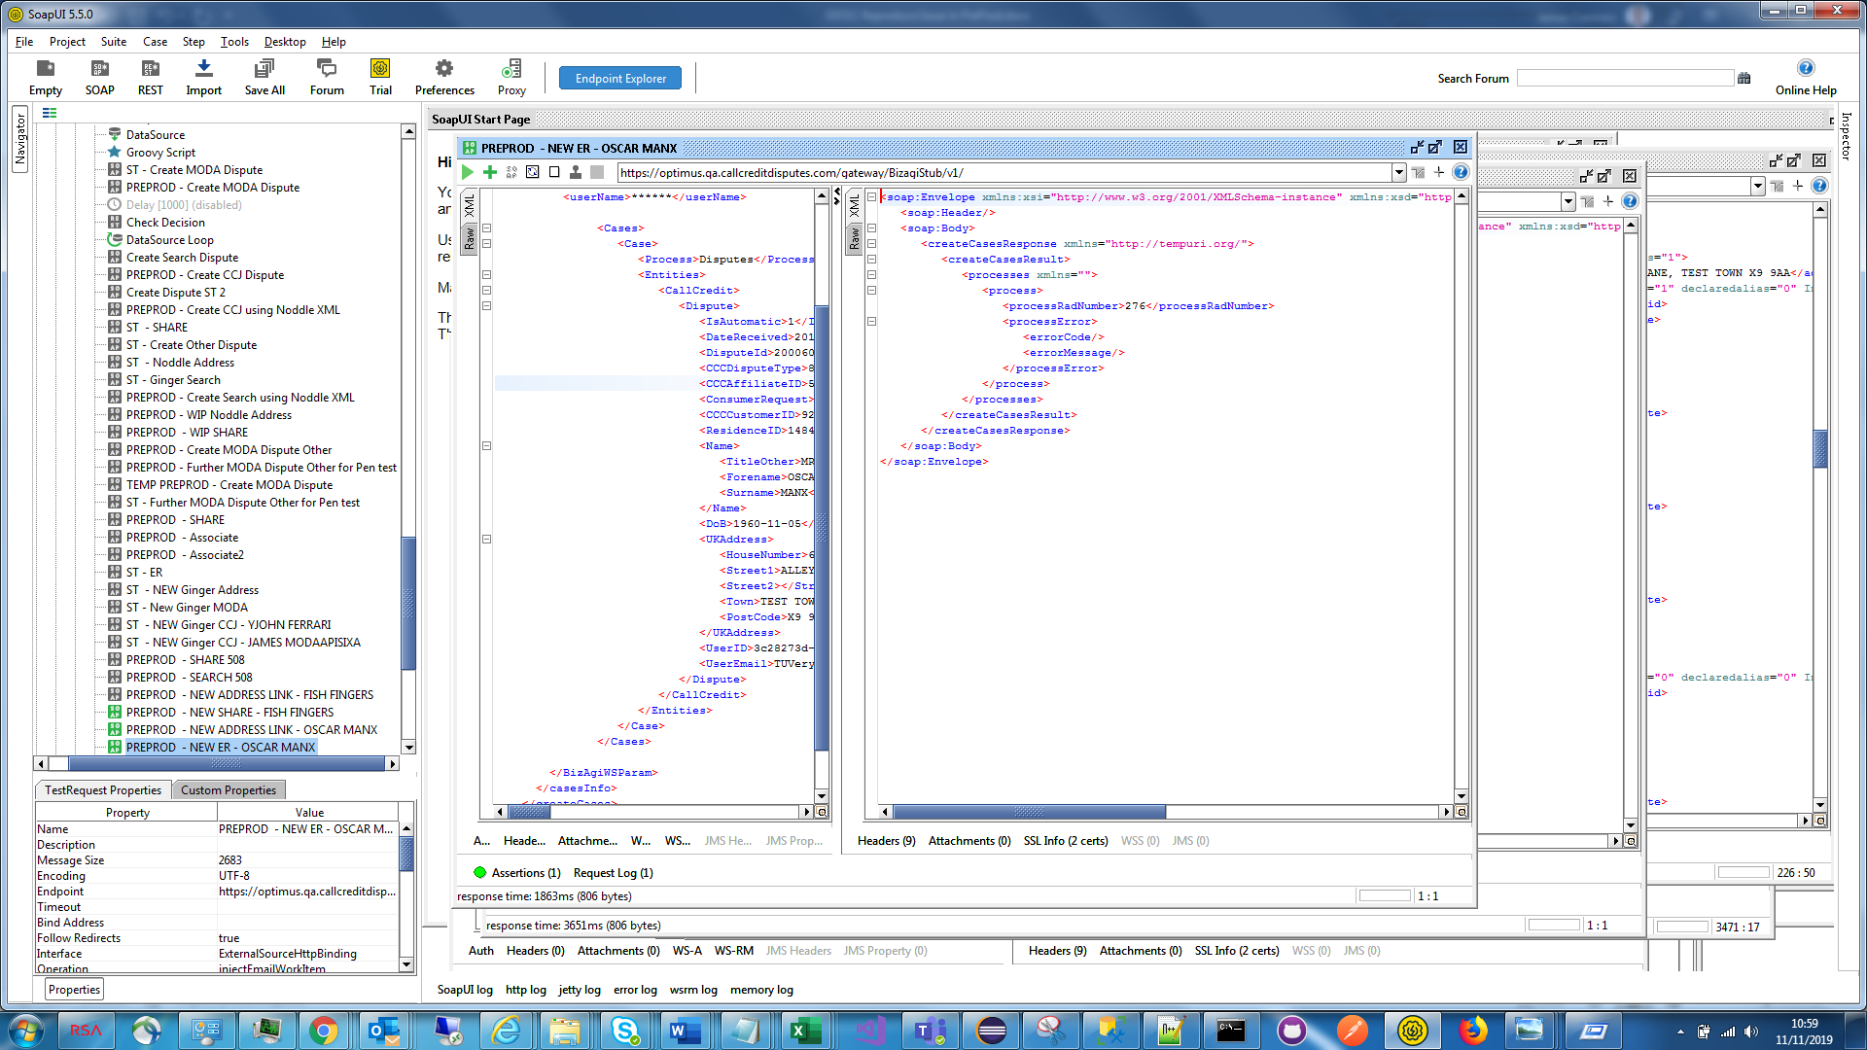

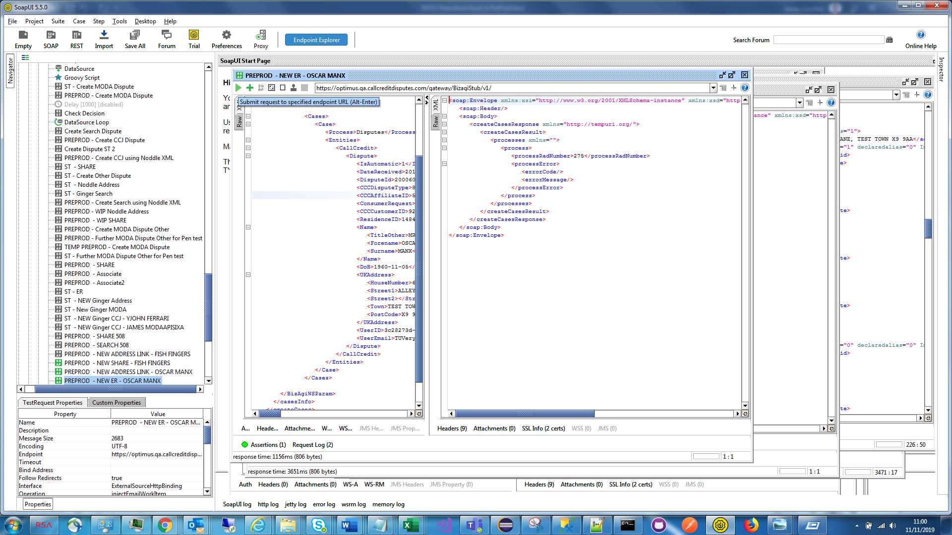

Same OSCAR MAX user in System Test;

